- for loop Scripts:
- Simple for loop output
- #!/bin/bash
- for i in 1 2 3 4 5
- do
- echo "Welcome $i times"
- done
- 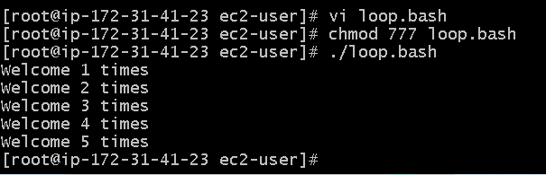

Simple for loop output
- #!/bin/bash
- for i in eat run jump play
- do
- echo See Imran $i
- done
- 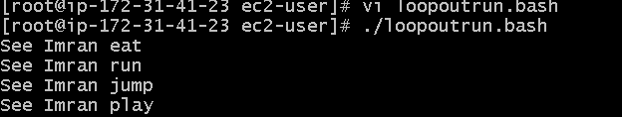

for loop to create 5 files named 1-5

- #!/bin/bash
- for i in {1..5}
- do
- touch $i
- done
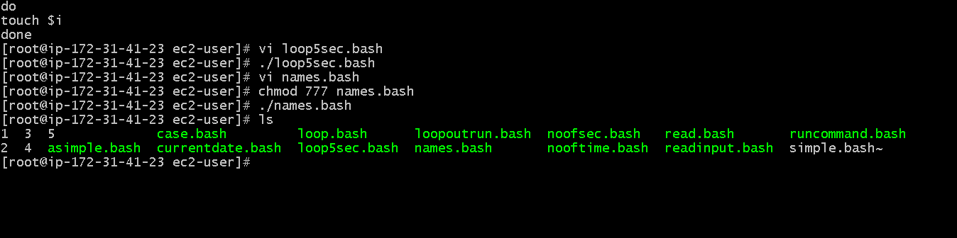

for loop to delete 5 files named 1-5

- #!/bin/bash
- for i in {1..5}
- do
- rm $i
- done
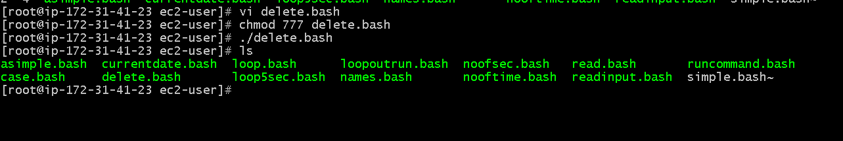

Specify days in for loop
- #!/bin/bash
- i=1
- for day in Mon Tue Wed Thu Fri
- do
- echo "Weekday $((i++)) : $day"
- done
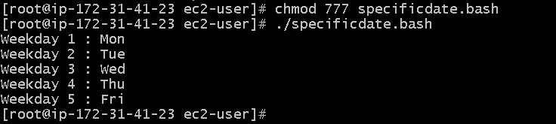
List all users one by one from /etc/passwd file
- #!/bin/bash
- i=1
- for username in `awk -F: '{print $1}' /etc/passwd`
- do
- echo "Username $((i++)) : $username"
- done
